**Spring Data JPA with Spring Boot and Hibernate**

**Introduction**

In modern enterprise Java development, managing interactions with databases forms a critical part of application architecture. To streamline this process, the Java ecosystem offers a combination of tools and frameworks: the Java Persistence API (JPA), Hibernate, and Spring Data JPA. These technologies build upon one another in layers, each addressing a specific aspect of data persistence to make it more consistent, maintainable, and easier for developers to work with. JPA defines the standard approach for mapping Java objects to relational database tables. Hibernate provides the actual implementation of this standard while offering enhanced features. On top of this, Spring Data JPA further simplifies development by reducing repetitive code through powerful abstractions. Gaining a clear understanding of how these three technologies function individually and collectively is essential for creating robust, data-driven Java applications.

**1. What is Java Persistence API (JPA)?**

JPA (Java Persistence API) is a specification that standardizes how Java objects interact with relational databases like MySQL or PostgreSQL.

**Key points:**

* JPA is just a set of interfaces — it does not include an actual implementation.
* It provides annotations such as @Entity, @Table, and @Id to map classes to tables.
* You need an implementation (like Hibernate or EclipseLink) to make JPA work.

**Example:**

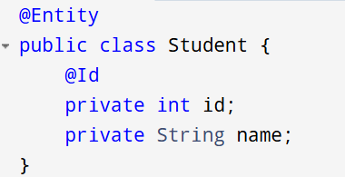

**Analogy:** Think of JPA as the blueprint for working with databases — it tells you *what* to do but not *how* to do it.

**2. What is Hibernate?**

Hibernate is a widely used Java framework for Object-Relational Mapping (ORM). It offers a concrete implementation of JPA and adds extra features.

**Key points:**

* It fully implements the JPA specification and goes beyond it with features like HQL (Hibernate Query Language) and caching.
* Maps Java objects to database records and manages CRUD operations.
* Handles operations such as insert, update, delete, and fetch.

**Example:**

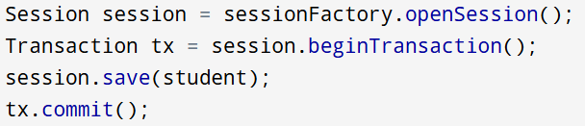

**Analogy:** If JPA is the recipe, then Hibernate is the chef who prepares the dish following that recipe.

**3. What is Spring Data JPA?**

Spring Data JPA is a module within the Spring Framework that builds on top of JPA to eliminate boilerplate code.

**Key points:**

* It is not a JPA implementation itself; it uses a JPA provider like Hibernate behind the scenes.
* Simplifies DAO (Data Access Object) creation by generating the implementation automatically.
* Provides interfaces like JpaRepository for easy CRUD operations.

**Example:**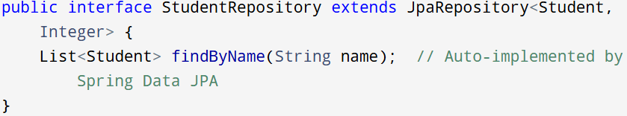

**Analogy:** Spring Data JPA acts like a kitchen helper who sets out your ingredients automatically so you can cook more efficiently.

**Differences Between JPA, Hibernate, and Spring Data JPA**

|  |  |  |  |
| --- | --- | --- | --- |
| **Aspect** | **JPA** | **Hibernate** | **Spring Data JPA** |
| **Type** | Standard Java specification (JSR 338) for ORM. | Full ORM framework implementing JPA. | Abstraction on top of JPA in the Spring ecosystem. |
| **Purpose** | Defines how to map Java objects to databases. | Provides JPA implementation with extra ORM features. | Simplifies JPA-based persistence with reduced boilerplate. |
| **Implementation** | Needs a provider (e.g., Hibernate) to work. | Supplies a complete JPA implementation plus extra features. | Relies on a JPA provider like Hibernate. |
| **Boilerplate** | Requires writing the persistence logic and DAOs manually. | Less verbose than JDBC but still needs session management. | Greatly reduces boilerplate by auto-generating repositories. |
| **Query Language** | Uses JPQL (Java Persistence Query Language). | Supports JPQL and its own HQL (Hibernate Query Language). | Supports JPQL, derived queries, and custom queries via annotations like @Query. |
| **Advanced Features** | Limited to what JPA specification defines. | Provides advanced ORM capabilities such as caching, interceptors, lazy loading, etc. | Relies on JPA provider’s features; does not add new ORM features on its own. |
| **Ease of Use** | Moderate; requires manual setup and code for DAOs and transactions. | Easier than plain JPA but still involves explicit session handling. | Easiest to use thanks to Spring Boot’s auto-configuration and interface-based repositories. |
| **Spring Integration** | Can integrate with Spring, but needs custom configuration. | Can be integrated with Spring manually or with Spring ORM. | Seamlessly integrated with Spring and Spring Boot. |
| **CRUD Operations** | Must be manually coded with Entity Manager. | Developers handle sessions and transactions for CRUD. | CRUD is handled automatically through repository interfaces. |
| **Transaction Handling** | Uses Entity Manager and requires manual demarcation or annotations. | Uses Hibernate Session, or integrates with Spring’s @Transactional. | Manages transactions declaratively with Spring’s @Transactional. |
| **Use Case** | Ideal for standards-based, vendor-independent persistence. | Good choice if you want detailed ORM features and flexibility. | Best if you need rapid development with tight Spring integration. |

**Code Comparison Between Hibernate, JPA, and Spring Data JPA**

1. **Hibernate**

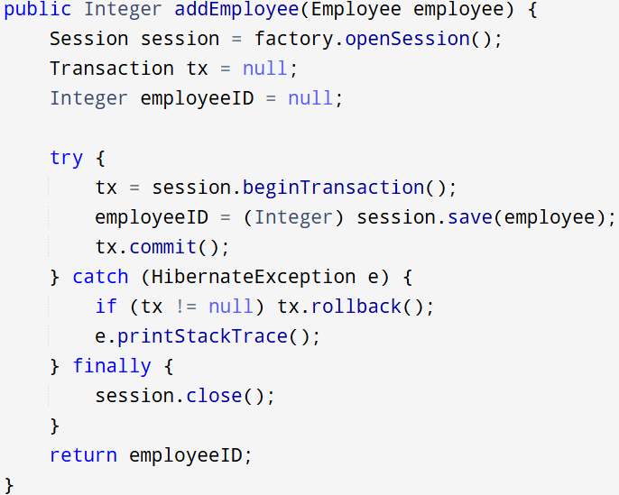

1. **Spring Data JPA**

* *EmployeeRepository.java*

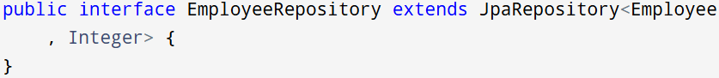

* *EmployeeService.java*

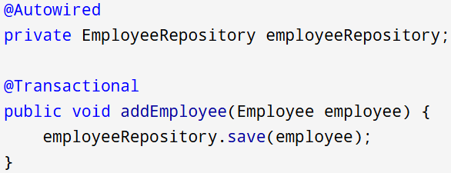

1. **JPA**

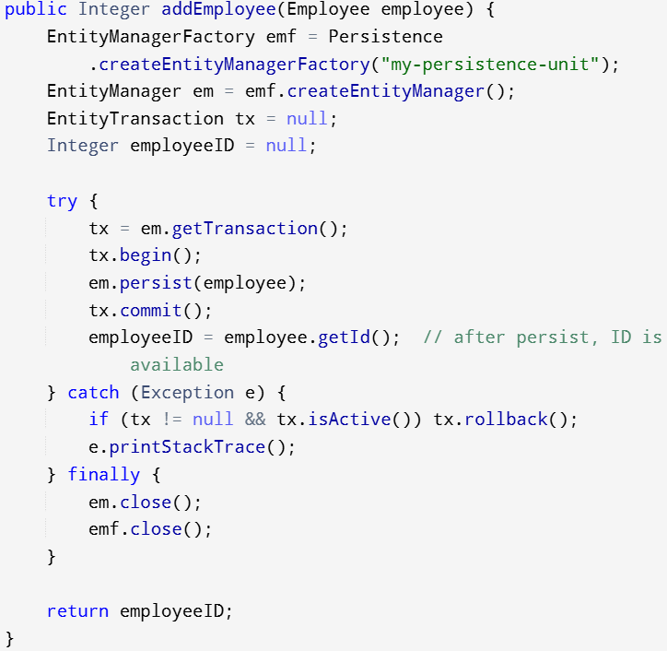

**Conclusion**

Hibernate, plain JPA, and Spring Data JPA all enable Java applications to persist data in relational databases, but they differ in their level of abstraction, complexity, and ease of use. JPA offers a standards-based approach to persistence but requires more manual coding and configuration. Hibernate, as a JPA implementation, brings additional ORM features like caching and a dedicated query language, simplifying certain aspects while still requiring explicit session management. Spring Data JPA takes the abstraction even further by leveraging Spring’s capabilities to remove most of the boilerplate code, making development faster and more convenient. Ultimately, JPA is ideal for strict standards compliance, Hibernate is well-suited for developers seeking advanced ORM features and more control, while Spring Data JPA is the best choice for rapid development within the Spring ecosystem.